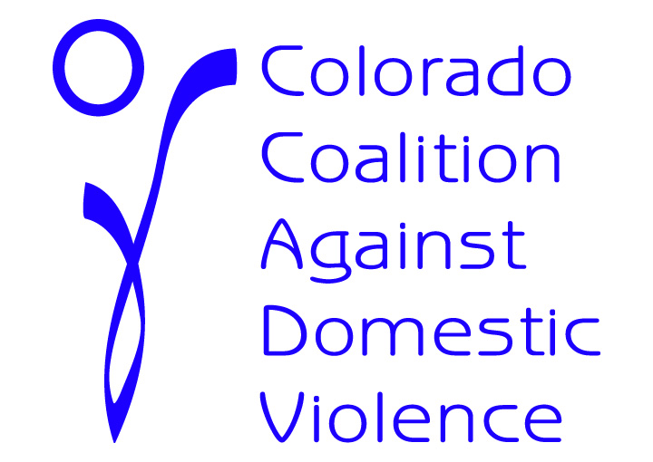
Enhancing Colorado’s Address Confidentiality Program
House Bill 11-1080
House Sponsor: Todd
Senate Sponsor: King

Background on current statute: The Address Confidentiality Program (ACP) was created under HB07-1350 to protect the confidentiality of the actual address of a victim of domestic violence, a sexual offense, or stalking who is about to relocate or who recently relocated to prevent the victim’s assailants or potential assailants from finding the victim through public records. Currently, an ACP participant must renew their certification in the program every 4 years and the renewal application must be signed and dated by an application assistant [CRS 24-21-205 (5)].

WHAT CHANGES TO THE LAW DOES THE BILL MAKE?
(Law Effective June 2, 2011)
Strengthens the ACP for current and future participants

- This bill will remove the requirement that renewal applications be signed and dated by an application assistant.
- This bill relocates the ACP from the Secretary of State’s Office to the Department of Personnel and Administration.
WHY DO WE NEED THIS?
Increases safety for victims of domestic violence, sexual assault and stalking
- The requirement that a victim’s renewal application be signed and dated by an application assistant is a barrier for victims seeking continued protections under the ACP.
  - The purpose of the renewal is to ensure all information on the prior application is current and to obtain consent for ongoing participation in the program.
  - To participate in the ACP, the victim must have already worked with an application assistant to determine eligibility for the program.
  - It is unnecessary and burdensome for a victim to locate and meet with an application assistant simply to renew their participation in the program. Application assistants could also better use their limited time and resources to assist victims who are in crisis and wish to enroll in the program.
- Relocating the ACP to the Department of Personnel and Administration enhances the security and efficiency of the Program and decreases the amount of funding used on administration so it can be used for services for Program participants.

For more information, please contact Amy Miller of the Colorado Coalition Against Domestic Violence at 303.968.5964 or amiller@ccadv.org or contact Annmarie Jensen of Jensen Public Affairs at 720.999.4795 or ajgovtrelations@gmail.com

